**List of Group Members (GHRCE)**

**Name**: Monika Sharma

**Contact no**: 08149043319

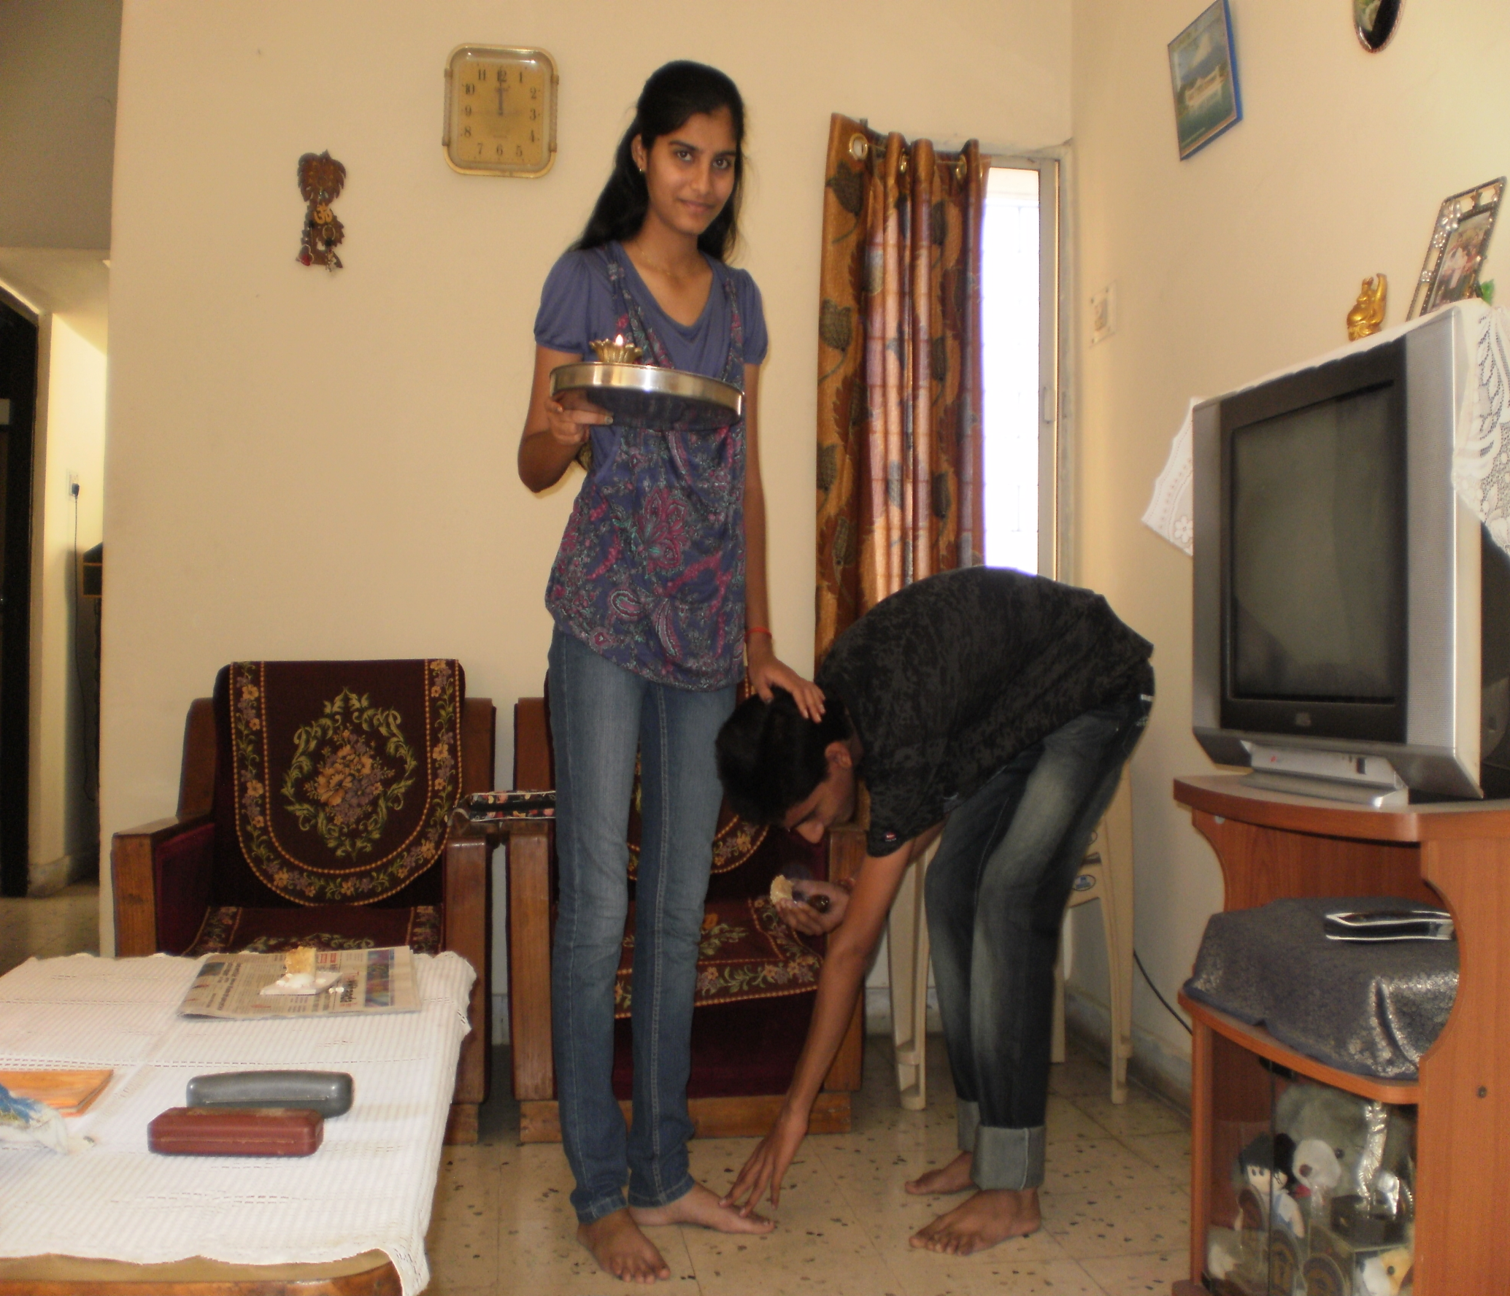

**Name**: Tarun Dhiraj

**Contact no**: 08657007790

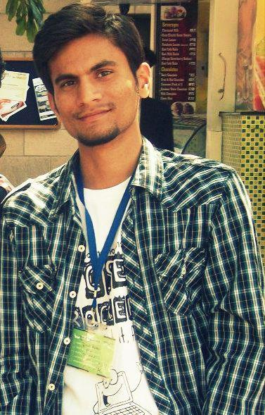

**Name**: Harshita Kapoor

**Contact no**: 08806266979

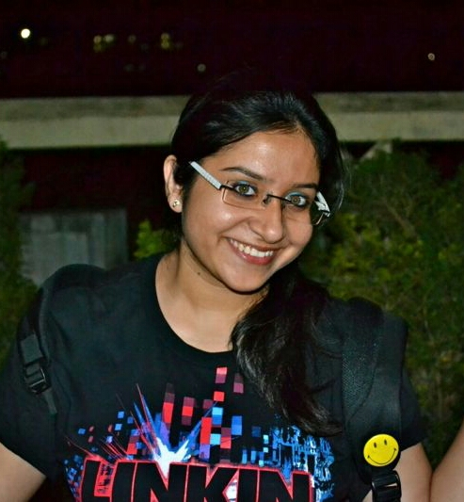

**Name**: Vivek Pillai

**Contact no**: 08793485943

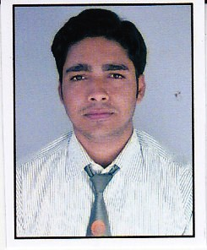

**Name**: Rohini Jaiswal

**Contact no**: 09561366454

